**The Issue**

In California, utilities, customer and consulting engineers and regulators need to exchange power system data to validate distributed energy resource plans, obtain permits, and verify compliance when integrating these resources in distribution systems. The data exchange process between the many different tools used can be cumbersome, slow and error prone. This raises a barrier to fast and effective resource integration, which limits the growth of these resources and places a limit on how quickly California can reach its climate change mitigation goals.

**Project Description**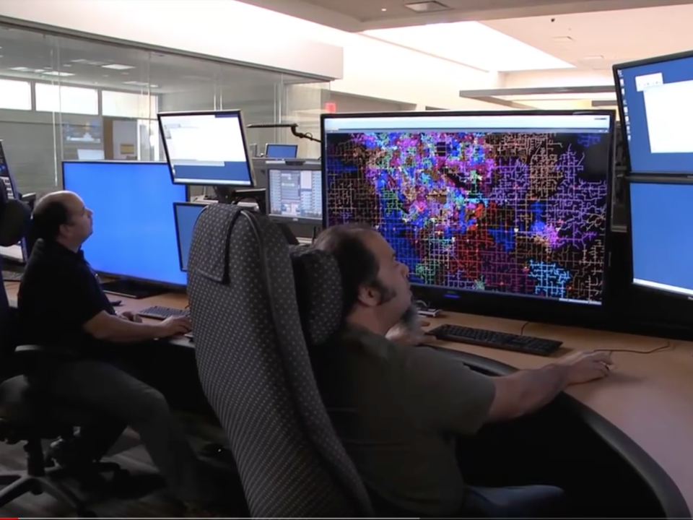

OpenFIDO is a data interchange, synthesis and analysis framework that provides information exchange between different power systems tools such as CYME, GridLAB-D, OpenDSS, Opal-RT and RTDS. The tool is used to transfer models and telemetry data between various tools that are part of the suite of tools widely used by utilities, distributed energy resource (DER) engineers and regulators in California. The tool is designed for utility planners and grid researchers that need a tool and integration framework to quickly move data from one application to another as part of their engineering, planning, and review activities. The tool also supports emerging user groups such as DER system integrators and aggregators that use multiple tools to limit the grid impacts of DERs, as well as governments and agencies that use these models in both their oversight role and identifying opportunities for clean energy deployments.

The long-term goals of OpenFIDO are to enable full interoperability between open-source software such as GridLAB-D and OpenDSS and various commercial power distribution system modeling tools such as CYME, Opal-RT, and RTDS. In addition, OpenFIDO is intended to support the easy development and adoption of new tools and analysis methodologies that depend on integrating diverse datasets available from these and other tools, metering systems, and data collection programs run by utilities, regulators, and commercial entities.

The objectives of the OpenFIDO project are:

1. *Produce a widely usable and fully functional data platform and interoperability layer for various power systems tools*, with special attention to the needs of IOU, CEC and CPUC users, as well as the vendors, consultants and researchers who support regulatory, planning and operations activities that are supported by tools based on GridLAB-D.
2. *Deliver a data exchange platform along with a set of data adapters* to convert data from power systems tools’ schema to a standardized, open-source format.
3. *Establish the foundation for long-term user and developer support*, including tools and services for data import, transformation, storage, access, and export.

**Anticipated Benefits for California**

OpenFIDO contributes multiple benefits to California’s electricity ratepayers by helping utilities work with customers and regulators ensure that DER are integrated more quickly, reliably, and cost-effectively into electricity distribution systems planning processes. Customer-based generation, storage and demand response resources must be planned in cooperation with utilities, and OpenFIDO provides the tools needed to facilitate a common data framework in which all parties can contribute and obtain the data they need to perform their respective activities quickly and accurately.

In addition, OpenFIDO provides a framework with which all tools used in DER resource financing, planning and permitting processes can interoperate. The capabilities of OpenFIDO will help utilities and other stakeholders more reliably and efficiently exchange system model data with analysts, regulators, and vendors. The reduction in labor intensity and cost of staff training will improve utility staff productivity, help expedite utility resource integration reviews, and simplify utility regulator compliance activities. All these work reductions will ultimately result in savings to ratepayers.

**Project Specifics**

Contractor: SLAC National Accelerator Laboratory, Menlo Park CA

Partners: GridWorks, Oakland CA (subcontractor)  
Pacific Northwest National Laboratory (subcontractor)  
National Grid, Hicksville NY (cost-sharing partner)

Amount: $1,000,000

Co-funding: $30,000 (cost-share)

Term: June 2018 to March 2023

Contact: David P. Chassin (dchassin@slac.stanford.edu)